1. Write a program to print the number of negative numbers in the list of numbers

Program:

def count_negative_numbers(arr):

return sum(1 for num in arr if num < 0)

array = [1, -2, 3, -4, 5, -6, 7, -8, 9, -10, 11, 12, -13, 14, 15]

print(f"Number of negative numbers in the array: {count_negative_numbers(array)}")

Output:

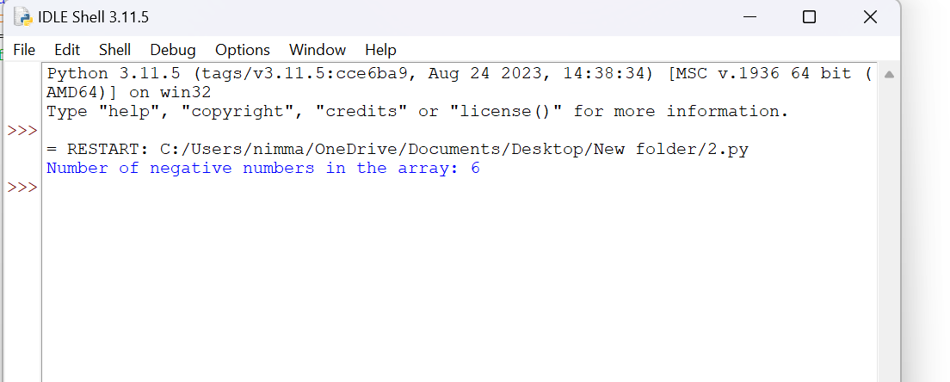

1. Write a program to merge two sorted lists to the third list

Program:

def merge_sorted_lists(list1, list2):

merged_list = []

i, j = 0, 0

while i < len(list1) and j < len(list2):

if list1[i] < list2[j]:

merged_list.append(list1[i])

i += 1

else:

merged_list.append(list2[j])

j += 1

while i < len(list1):

merged_list.append(list1[i])

i += 1

while j < len(list2):

merged_list.append(list2[j])

j += 1

return merged_list

sorted_list1 = [1, 3, 5, 7, 9]

sorted_list2 = [2, 4, 6, 8, 10]

merged_list = merge_sorted_lists(sorted_list1, sorted_list2)

print(f"Merged sorted list: {merged_list}")

Output:

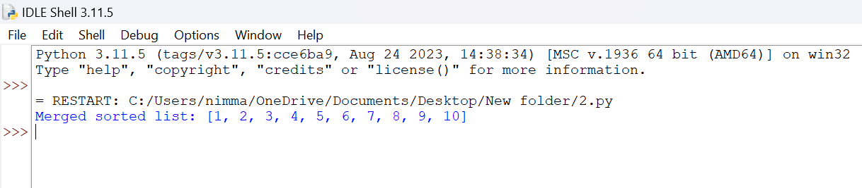

1. Write a program to insert an element in a specific index

Program:

def insert_element(lst, index, element):

if index < 0 or index > len(lst):

raise IndexError("Index out of range")

lst.insert(index, element)

return lst

my_list = [1, 2, 4, 5]

index_to_insert = 2

element_to_insert = 3

updated_list = insert_element(my_list, index_to_insert, element_to_insert)

print(f"Updated list: {updated_list}")

Output:

